

Software Requirement Specification

**Version1.1**

**Nhan Pham**

**18/11/2019**

**VERSION HISTORY**

|  |  |  |  |  |  |
| --- | --- | --- | --- | --- | --- |
| **Version #** | **Implemented**  **By** | **Revision**  **Date** | **Approved**  **By** | **Approval**  **Date** | **Reason** |
| 1.0 | Quốc Nhân | 04/11/2019 |  |  | Create Document SRS version 1.0 |
| 1.1 | Quốc Nhân | 18/11/2019 |  |  | Update Document SRS version 1.1 |
|  |  |  |  |  |  |
|  |  |  |  |  |  |

Table of Contents

1. Introduction 3

1.1 Purpose 3

1.2 Intended Audience and Reading Suggestions 3

1.3 References 3

2. Overall description 3

2.1 Function Perspective 3

2.2 Groups and Characteristics 3

2.3 Operating Environment 3

2.4 **Design and Implementation Constraints** 3

2.5 Assumptions and Dependencies 3

3. External Interface Requirements 3

3.1 User Interfaces 3

3.2 Hardware Interfaces 3

3.3 Software Interfaces 3

3.4 Communications Interfaces 3

4. USE CASES 3

5. SYSTEM FEATURES 3

5.1 Feature Perspective 3

5.2 Groups and Characteristics 3

6. data requirements 3

1.1 Data Logical Model 3

1.2 Data Dictionary 3

7. Quality attributes 3

# 

# Introduction

## Purpose

The real estate application is created by the 'Hello World' group and the file is created to determine the role, flow of user, quality attributes, functions, and data dictionary.

## **Intended Audience and Reading Suggestions**

* Leader
* Department head
* Employees
* Administrator

## References



# Introduction

## Function Perspective

* Account management
* Project management
* Statistical management, reporting
* Business trip manager
* Management quit
* Other functions

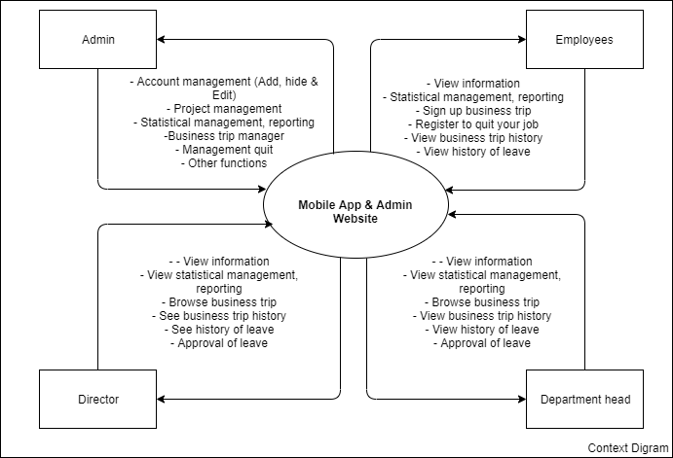

## **User Groups and Characteristics**

|  |  |  |
| --- | --- | --- |
| **#** | **User Groups** | **Descriptions** |
| 1 | Director | - View information  - View statistical management, reporting  - Browse business trip  - See business trip history  - See history of leave  - Approval of leave |
| 2 | Department head | - View information  - View statistical management, reporting  - Browse business trip  - See business trip history  - See history of leave  - Approval of leave |
| 3 | Administrator | - Account management (Add, hide & Edit)  - Project management  - Statistical management, reporting  -Business trip manager  - Management quit  - Other functions |
| 4 | Employees | - View information  - Statistical management, reporting  - Sign up business trip  - Register to quit your job  - View business trip history  - View history of leave |

## Operating Environment

* Internet request system.
* Mobile app only supported on Android and IOS operating systems
* All data saved at real estate company

## **Design and Implementation Constraints**

Customer:

* Easy to interact
* Optional color
* Implementation on the App Android & IOS

## Assumptions and Dependencies

* Customers provide ANDROID and IOS accounts

# External Interface Requirements

## User Interfaces

## **Hardware Interfaces**

## Software Interfaces

## **Communications Interfaces**

# Use cases



# System Features

## Feature Perspective

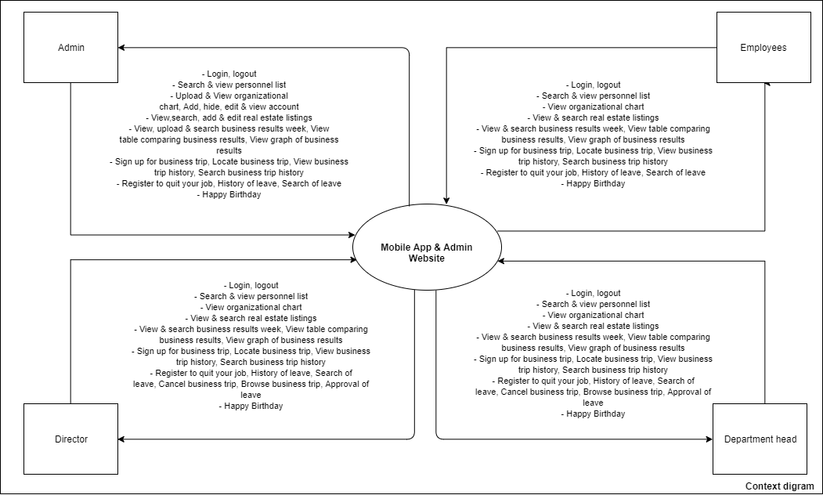

## **User Groups and Characteristics**

|  |  |  |  |  |
| --- | --- | --- | --- | --- |
| **ID** | **FEATURES** | **DESCRIPTION** | **CLASSIFY** | **Priority** |
| **Account management** | | | | |
| FR.01 | Login | Users are provided accounts from the admin | Employees, department head, director and administrator | High |
| FR.02 | Logout | High |
| FR.03 | View account information |  | Administrator | Medium |
| FR.04 | Search personnel list | Users can search for personnel | Employees, department head, director and administrator | Medium |
| FR.05 | View personnel list | View image on app | Employees, department head, director and administrator | Medium |
| FR.06 | Upload organizational chart | Admin upload & add organizational chart | Administrator | Medium |
| FR.07 | View organizational chart | View image on app | Employees, department head, director and administrator | Medium |
| FR.08 | Add company policy | Admin add, edit & delete company policy | Administrator | Medium |
| FR.09 | Edit company policy | Medium |
| FR.10 | Delete company policy | Medium |
| FR.11 | View company policy | View image on app | Employees, department head, director and administrator | Medium |
| FR.12 | Add account |  | Administrator | High |
| FR.13 | Hide account | High |
| FR.14 | Edit account | High |
| FR.15 | Decentralization | High |
| **Real estate project management** | | | | |
| FR.16 | View real estate listings |  | Employees, department head, director and administrator | High |
| FR.17 | Search real estate listings | Medium |
| FR.18 | Add real estate listings |  | Administrator | High |
| FR.19 | Edit real estate listings | Medium |
| **Statistical management, reporting** | | | | |
| FR.20 | View business results week | After the admin receives statistical information, reports from the company, the admin will display on the app | Employees, department head, director and administrator | High |
| FR.21 | Upload business results week | After the admin receives statistical information, reports from the company, the admin will upload on the app | Administrator | High |
| FR.22 | Search business results week |  | Employees, department head, director and administrator | High |
| FR.23 | View table comparing business results | High |
| FR.24 | View graph of business results | High |
| **Business trip manager** | | | | |
| FR.25 | Sign up for business trip | Employees, department head, director and administrator will register the business trip | Employees, department head, director and administrator | High |
| FR.26 | Browse business trip | Director & department head will confirm | Director, departments head | High |
| FR.27 | Cancel business trip | Director & Head of Department will refuse | Director, departments head | High |
| FR.28 | Locate business trip | After completing the business trip | Employees, department head, director and administrator | High |
| FR.29 | View business trip history | Entire company can review history | Employees, department head, director and administrator | High |
| FR.30 | Search business trip history |  | Employees, department head, director and administrator | High |
| **Management quit** | | | | |
| FR.31 | Register to quit your job | Employees, department head, director and administrator will register the day off | Employees, department head, director and administrator | Medium |
| FR.32 | History of leave | Entire company can review history | Employees, department head, director and administrator | Medium |
| FR.33 | Approval of leave | Director & department head will review and approve the leave | Director, departments head | Medium |
| FR.34 | Search of leave |  | Employees, department head, director and administrator | Medium |
| **Other functions** | | | | |
| FR.35 | Happy Birthday | The app will display a happy birthday notification for everyone (on staff's birthday). | System (popup) | Low |

# Introduction

## Data Logical Model

## **Data Dictionary**

|  |  |  |  |  |
| --- | --- | --- | --- | --- |
| **#** | **Entity** | **Attribute Name** | **Attribute Type** | **Required (Y/N)** |
| *1* | *Sinh viên* | *MSSV* | *Varchar(20)* | *Y* |
|  |  | *Họ tên* | *Varchar(60)* | *Y* |
|  |  | *Ngày sinh* | *Datetime* | *Y* |
|  |  | *Giới tính* | *Text* | *Y* |
|  |  | *Số điện thoại* | *Number Datetime* | *Y* |
|  |  | *Email* | *Text* | *Y* |
|  |  | *Lớp* | *Varchar(20)* | *Y* |
| *2* | *Admin* | *Mã Admin* | *Varchar(20)* | *Y* |
|  |  | *Tên tài khoản* | *Varchar(50)* | *Y* |
|  |  | *Mật khẩu* | *Text* | *Y* |
| *3* | *Tài khoản* | *Tên tài khoản* | *Varchar(50)* | *Y* |
|  |  | *Mật khẩu* | *Text* | *Y* |
| *4* | *Lịch học* | *ID* | *Int(11)* | *Y* |
|  |  | *Năm* | *Datetime* | *Y* |
|  |  | *Học kì* | *Varchar(20)* | *Y* |
|  |  | *Lớp* | *Varchar(20)* | *Y* |
|  |  | *Khóa* | *Varchar(20)* | *Y* |
| *5* | *Giáo vụ* | *Mã giáo vụ* | *Varchar(20)* | *Y* |
|  |  | *Tài khoản* | *Varchar(50)* | *Y* |
|  |  | *Mật khẩu* | *Text* | *Y* |
| *6* | *Lịch thi* | *ID* | *Int(11)* | *Y* |
|  |  | *Khóa* | *Varchar(20)* | *Y* |
|  |  | *Kì thi* | *Varchar(20)* | *Y* |
|  |  | *Năm* | *Datetime* | *Y* |
| *7* | *Điểm học kỳ* | *ID* | *Int(11)* | *Y* |
|  |  | *MSSV* | *Varchar(20)* | *Y* |
|  |  | *Điểm lần 1* | *Varchar(20)* | *Y* |
|  |  | *Điểm lần 2* | *Varchar(20)* | *Y* |
|  |  | *Điểm tổng* | *Varchar(20)* | *Y* |
|  |  | *Lớp* | *Varchar(20)* | *Y* |
|  |  | *Họ tên sinh viên* | *Varchar(60)* | *Y* |
|  |  | *Học kỳ* |  | *Y* |
| *8* | *Công tác sinh viên* | *Mã số CTSV* | *Varchar(20)* | *Y* |
|  |  | *Tài khoản* | *Varchar(50)* | *Y* |
|  |  | *Mật khẩu* | *Text* | *Y* |
| *9* | *Học phí* | *ID* | *Int(11)* | *Y* |
|  |  | *MSSV* | *Varchar(20)* | *Y* |
|  |  | *Số tiền* | *Number* | *Y* |
|  |  | *Tình trạng* | *Text* | *Y* |
|  |  | *Họ tên sinh viên* | *Varchar(60)* | *Y* |
|  |  | *Lớp* | *Varchar(20)* | *Y* |
| *9* | *Học bổng* | *ID* | *Int(11)* | *Y* |
|  |  | *MSSV* | *Varchar(20)* | *Y* |
|  |  | *Họ tên sinh viên* | *Varchar (60)* | *Y* |
|  |  | *Lớp* | *Varchar(20)* | *Y* |
|  |  | *Trạng thái* | *Text* | *Y* |
| *10* | *Điểm rèn luyện* | *ID* | *Int(11)* | *Y* |
|  |  | *MSSV* | *Varchar(20)* | *Y* |
|  |  | *Lớp* | *Varchar(20)* | *Y* |
|  |  | *Họ tên sinh viên* | *Varchar(60)* | *Y* |
|  |  | *Điểm rèn luyện* | *Varchar(20)* | *Y* |

# Quality attributes.

* Usability
* Performance
* Testability
* Availability
* Portability

|  |  |  |  |
| --- | --- | --- | --- |
| **#** | **ID** | **Quality Attributes** | **Priority** |
| **Usability** | | | |
| 1 | QA1 | Chức năng đơn giản và bố trí một cách hợp lý cho người sử dụng | High |
| 2 | QA2 | Giao diện đơn giản dễ sử dụng. | High |
| **Performance** | | | |
| 3 | QA3 | Thời gian tải trang phải thấp (tối thiểu 3 giây) | High |
| 4 | QA4 | Hệ thống phải đáp ứng hỗ trợ nhiều người sử dụng cùng lúc (trên dưới 100 người) | High |
| **Testability** | | | |
| 5 | QA5 | Hệ thống thực hiện đúng với chức năng đó từ yêu cầu người dùng. | High |
| **Availability** | | | |
| 6 | QA6 | Hệ thống luôn luôn hoạt động khi sự cố xảy ra. (luôn có khi người dùng muốn sử dụng) | High |
| **Portability** | | | |
| 7 | QA7 | Hệ thống có thể chạy được trên hệ điều hành. (Android & IOS) | High |